附件2
广西工商职业技术学院2023年学生技能竞赛英语口语赛项初赛规程
一、初赛时间
2023年12月23日
二、形式和内容
（一）竞赛形式：初赛为现场比赛，包括中国故事（定题演讲，3分钟）、职场描述（图表描述，3分钟）和情景交流（3分钟）三个比赛环节。现场评委根据选手表现进行打分，根据比分由高到低评选出12名参赛选手进入决赛。
（二）竞赛内容：
1.“中国故事”（Speech）： 参赛选手根据题目的要求进行定题演讲，讲述中国故事，介绍中华文化。演讲应主题鲜明，弘扬社会正气，传递正能量，不能透露个人信息，不能涉及商业广告。每位参赛选手用时不超过3 分钟。
2.“职场描述”（Presentation）：参赛选手抽取一幅反映行业、企业业务发展或社会、经济等热点问题的统计图表或图片，根据给出的说明，在充分理解图表或图片内容的基础上对其进行口头描述和观点阐述。每位选手用时不超过3分钟。
3.“情景交流”（Interview）：参赛选手抽取一个场景题目，根据题目的要求扮演其中的一个角色，与考官进行一对一的现场问答式交流。每位选手用时不超过3分钟。
三、初赛试题
（一）中国故事
背诵短文 Grandpa’s Medal
My grandpa has a treasure. It was me, but from last year it became a medal which was bestowed for honoring the 50th anniversary of being a communist. Yeah, my grandpa has been a Party member over 50 years. I’m so proud of him! I still remember his expression when he received the medal, nervous, excited, and choked with emotion. After a while, he said in a quavering voice “The CPC didn't forget me. The recent decades has witnessed great changes in China. That's really amazing!” From his eyes, I think I saw thousands of unknown senior Communists like grandpa. Over the past half-century, those seniors pledged to striving for the good of the people and the country. They have worked diligently for the Communist cause, silent dedication, and made great achievements. Every medal represents an individual struggling experience; it's their dedication that we can live in today’s peaceful life.
Grandpa is 80 years old this year; the medal is an affirmation for his past life. I am only 19, and I didn't get involved in the Chinese revolution. But I know countless communist took part in it and fight for all life. They are the reddest part in the river of Chinese history.
That afternoon, grandpa changed a formal clothes and wore the medal for 2 photos. The medal has been the apple of grandpa's eyes since that day and he looks at it every day. For me the medal is not just a metal, but something greater than personal existence. I have to admit that I received a belief education in this matter. From an early age, I want to be somebody and make something big, but it's all talk. Now I know that to be a better person, what I should do is anything meaningful rather than something only seems big.

（二）职场描述
描述图表，并阐述观点。
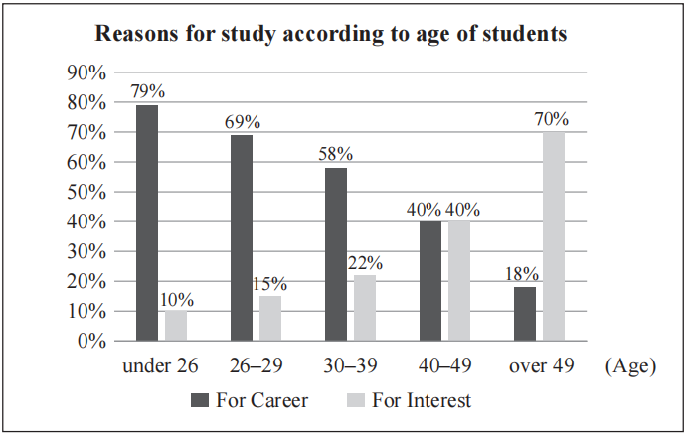
You are required to talk about the following bar chart, shows the main reasons for study among students in different age groups. You should describe the chart, analyze the possible causes reflected within, and make some predictions/suggestions/comments. Your presentation should be completed within 3 minutes.

（三）情景交流
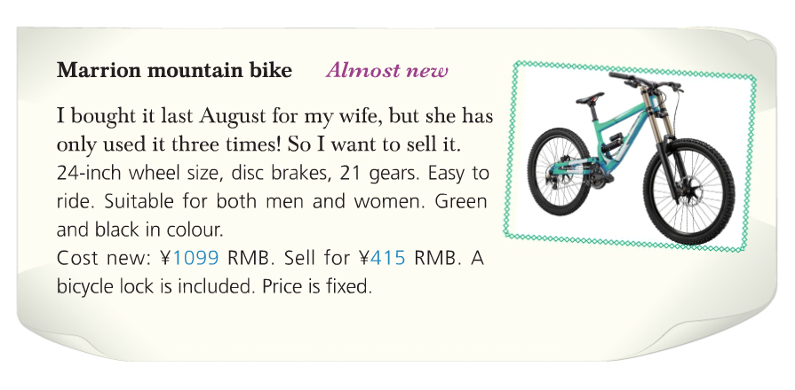
根据以下图片与评委做一对一情景交流。
Suppose you are the owner of the bike.
You are talking with a person who is interested in the bike offered in the advertisement.
You will answer the questions from the person.
Your answer should be completed within 3 minutes.

